

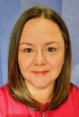


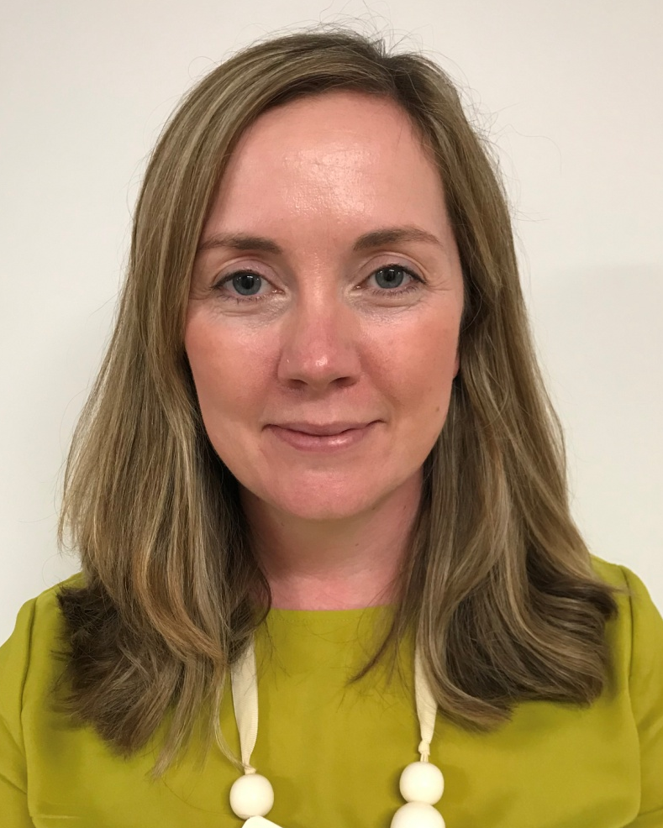
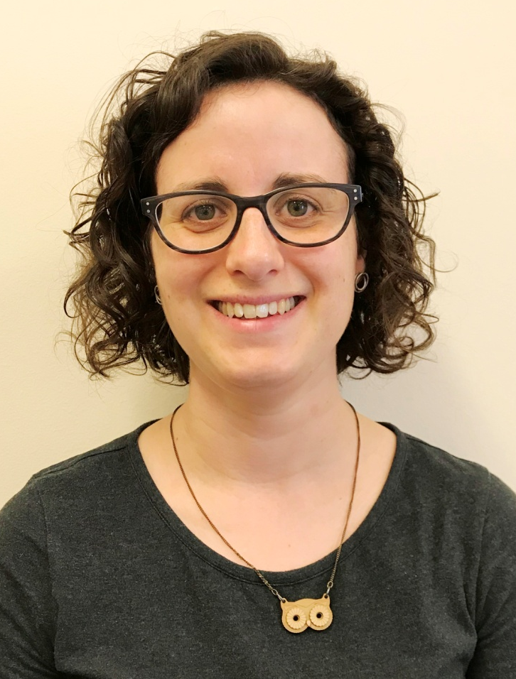
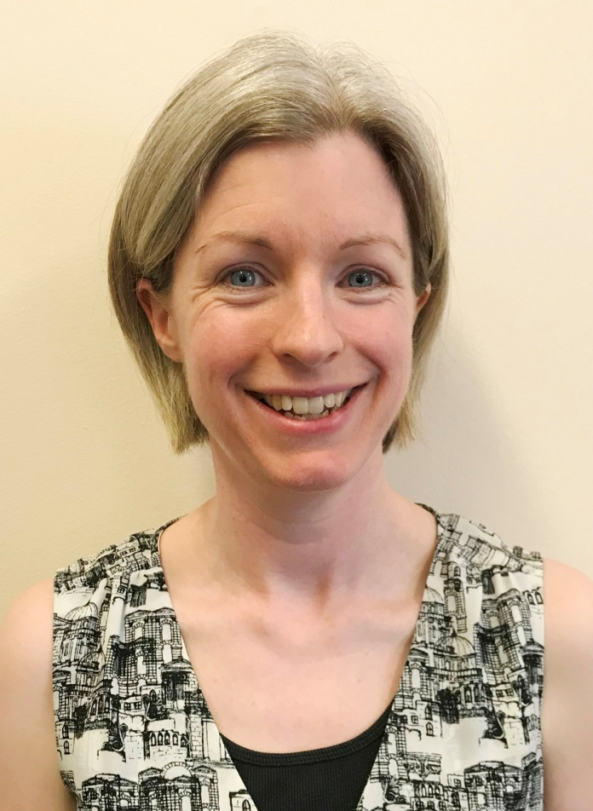
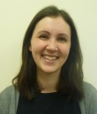
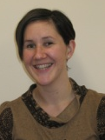
PRACTICE
INFORMATION
LEAFLET
2026

The Balfour
Foreland Road
KIRKWALL
KW15 1NZ

Tel 888240

www.skerryvorepractice.co.uk

Out of Hours Emergencies:
111

There is full access for disabled patients.

PRACTICE
AREA
PRACTICE
Skerryvore
Kirkwall
St Ola
Orphir
Firth
Finstown
Stenness
Toab
Deerness
Tankerness
Holm

HEALTH BOARD

Our local Health Board is NHS Orkney and the Primary Care Department can be contacted via The Balfour, Kirkwall,
Telephone 888 066 (Head of Primary Care Services).

Updated 23 September, 2026


DOCTORS
All of the Doctors listed below form a Partnership.

Dr Sarah Stevenson
MB ChB, DFFP, MRCGP, GMC No 6055564,
Trainer

Dr Kirsty Cole
MBE, MB ChB, BSc Med Sci, FRCGP,
GMC No 6115432

Dr Fiona Cook
MB ChB, MRCGP, DRCOG, DFSRH, GMC No 6115314

Dr Anne Tierney
BSc, MB ChB, MRCGP, GMC No 6151214

Dr Ingrid Norquay
MB ChB, MRCGP, DRCOG, DFSRH, GMC No 6163202

Dr Richard Brunt
MB ChB, MRCGP, GMC No 6055950

Dr Liz Johnston
BSc, MB ChB, MRCGP, GMC No 6145574
Trainer

Dr Jamie Stevenson
BSc, MB ChB, MRCGP, DRCOG, GMC No 7074274

Dr Selali Fiamanya – Salaried GP
GMC No 7556728

We also host experienced locum GPs throughout the year to provide cover when our GP Partners are on leave. You will be told who your clinician is at the time of booking.

PATIENTS RIGHTS & RESPONSIBILITIES TO THE NHS

A leaflet regarding Patients’ Rights and Responsibilities to the NHS can be obtained from the Receptionist or downloaded from our website.

The Practice does not tolerate abuse to staff, whether verbal or physical. The Practice has the right to request the removal of any patient from the practice list if unreasonable or abusive behaviour is displayed.

CPRD (Clinical Practice Research Datalink)

Information in patient records is important for medical research to develop new treatments and test the safety of medicines. Skerryvore Practice supports medical research by sending some of the information from patient records to the Clinical Practice Research Datalink (CPRD).

CPRD data services from the Medicines and Healthcare products Regulatory Agency provide anonymised patient data for research to improve patient and public health.

If you do not want anonymised information from your patient record to be used in research you can opt out by contacting the Practice.

For more information about CPRD and how your data is used visit www.cprd.com/public

The information in this leaflet is in no way intended to replace the professional medical care, advice, diagnosis or treatment by a doctor. If you notice medical symptoms or feel ill you should consult your doctor.

.

PATIENT CONFIDENTIALITY

All members of the practice team treat patient information in the strictest confidence.

Skerryvore Practice complies with Data Protection & Access to Medical Records legislation. Identifiable information about you will be shared with others in the following circumstances:

- To provide further medical treatment for you e.g. from district nurses, Out of Hours and hospital services
- To help you access other services e.g. Out of Hours GP
- When we have a duty to others e.g. in child protection cases

If you do not wish anonymous information about you to be used in such a way, please let us know.

GDPR

The Practice fully complies with the new General Data Protection Act (GDPR). Further information is available in our leaflet “What is GDPR” which can be found on or website or you can ask at the Practice for a copy.

Our Privacy Notice can also be viewed on our website or obtained from the Practice.

PRACTICE POLICIES

Further information regarding our Practice Policies can be found on our practice website, these include:

- Zero Tolerance
- Confidentiality and Medical Records
- Access to Records
- Complaints

PRACTICE MANAGERS

Deborah Stove and Lanna Conlon

Our Practice Managers are involved in managing all of the business aspects of the Practice including equipment, premises, finance, patient safety and employment of staff.

Along with the GPs the Practice Manager ensures that the right systems are in place to provide a high standard of quality care.

PRACTICE DEVELOPMENT

We work constantly to improve the practice and would welcome any suggestions, comments or complaints on the service we provide. Please speak or write to Deborah Stove, Practice Manager or leave a note in the comments box situated on the wall to the left of our Reception Desk.

COMPLAINTS

If you have a complaint or concern about the service you have received from the doctors or any of the staff working in the Practice, please let us know. Complaints should be addressed to Deborah Stove, Practice Manager. Further information is available in our Practice Complaints Leaflet which is available from the Practice or downloadable from our website.

5A

PRACTICE SERVICES

We provide complete general medical services including:

- Full maternity care
- Contraception (including coil, cap, implant fittings, free condoms, emergency contraception, sterilisation and Depo)
- Minor surgical operations (e.g. removal of skin cysts)
- Child Health Development Clinics
- Referrals to other health professionals (including Community Psychiatric Nurses, Dietitian, Physiotherapists etc.)
- Sexual Health Screening

PRACTICE CLINICS

Diabetic Clinic
Our diabetic patients are invited to this clinic annually.

Childhood Vaccinations
These are carried out by the Vaccination Team at The Balfour.

Cardiovascular Disease Clinic
Our patients with either high blood pressure, heart disease, kidney disease or stroke will be invited for an annual ‘MOT’ check once per year with the nurse. Appointments are usually by invitation.

Asthma Clinic
Led by our Advanced Nurse Practitioner and Practice Nurse, patients are invited annually.

Antenatal Clinics are held at Maternity, The Balfour – Tel: 888238

PRIVATE MEDICAL EXAMINATIONS

Certain times are set aside for performing private medical examinations (e.g. LGV/PCV, Diving, and Life Insurance). A special appointment is always required.

OFFICE STAFF

Office Supervisor

Charlie Taylforth

Our Office Supervisor supports our staff to ensure the smooth day to day running of the Practice. She ensures office processes and procedures are maintained and working effectively.

Medical Secretaries

All our reception staff are involved in general office duties:

Christine Harcus Eilidh Scott
Danielle Flett Kimberley Croy
Paula Spence Morven Stevenson
Morag Cole Alanna Smith
Fiona Dancy Emily Scott
Nicola Hourston Shani Patching

Our Secretaries’ role is to be “front of house” and they are here to welcome patients and visitors and successfully deal with many sensitive, urgent and intricate patient enquires. They capably prioritise and deal with a multitude of complex systems and procedures. It is for this reason that you may be asked for additional medical information.

7
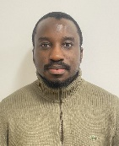

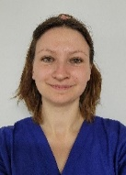


GENERAL PRACTITIONER TRAINING cont.

GENERAL PRACTICE SPECIALIST TRAINEES (GPST1 and GPST3)

These are doctors, who have completed at least 2 years working in hospital and have now chosen to specialise in General Practice. They work in the Practice for 6 months in their first year (GPST1) and for 12 months in their last year of GP training (GPST3). They will take on clinical responsibility but can still refer to a supervising GP for advice if needed. After successful completion of training, they will be fully qualified GPs. As part of training we sometimes videotape consultations. This only happens with patient’s written consent. Our current GPSTs are:

FOUNDATION YEAR 2 (FY2)

An FY2 is a fully qualified doctor who has graduated and has completed one year of hospital-based training. In their second year, they undertake structured training designed to broaden their experience across various medical specialties, including general practice. FY2 doctors work under supervision, gradually taking on more responsibility for patient care while continuing to develop their clinical skills. Our current FY2 is:

NON-MEDICAL TRAINING

The Practice also supports a variety of health care workers to gain additional qualifications, for example in prescribing or clinical examination. You may find you are asked if you mind a nurse, pharmacist or physiotherapist sitting in on your consultation. Like all persons working at the practice, they are fully bound by the rules of confidentiality and professional accountability.

Dr Romade Ope-Ewe
GPST1, GMC: 7738706

Dr Muhammad Ahmed
GPST1, GMC: 7672422

Dr Megan Hutchinson
GPST 3, GMC: 7669925

Dr Joanne Land FY2
GMC: 8117770

ADVANCED NURSE PRACTITIONER
Ian Hall - Telephone: 888240

Our Advanced Nurse Practitioner helps to support the doctors by carrying out the following:

- Assisting with patient triage
- COPD and Asthma Management
- Cardiovascular Disease Clinics

PRACTICE NURSES
Louise Stevenson - Telephone: 888240

Our Practice Nurses help to support the Doctors by carrying out the following:

- Cervical Cytology
- Contraception Services
- Specialised Diabetic and Cardiovascular Disease
- General Healthy Lifestyle Advice

Shona Peace & Karen Leask - Telephone: 888240

- Wound Management • Spirometry
- Doppler • Depo

HEALTH CARE ASSISTANTS
Diane Petrie & Kerri Brown - Telephone: 888240

Our Health Care Assistants have been trained and supervised to a high standard by our doctors and nurses. They are available for blood tests, BP checks, ECGs, Vitamin B12 Injections and to assist and support the GPs.

5A

GENERAL PRACTITIONER TRAINING

We are a training practice, accredited with the NHS Education for Scotland Deanery.

HEALTHCARE PROFESSIONALS IN TRAINING

It is vital for the future of the NHS that we train enough healthcare professionals, such as doctors, nurses, pharmacists, physiotherapists etc. You may meet various healthcare professionals at different stages of training when being looked after by Skerryvore Practice.

Through exposure to the excellent training opportunities within our practices, we hope that this will lead to a sustainable workforce with new GPs keen to come and work here in the future!

Below are the different kinds of students and trainees working here:

MEDICAL STUDENTS

We provide 1 year educational placements for 3rd year ScotGEM medical students from Dundee. ScotGEM is a four-year graduate entry medical programme. It is designed to develop doctors interested in a career as a generalist practitioner within NHS Scotland. The programme is tailored to meet the current and future needs of the NHS in Scotland and focuses on rural medicine and healthcare improvement.
Medical students will always be working under the close supervision of a named experienced GP who will be at hand for advice or support as necessary.
On completing their medical degree, medical students become licenced by the General Medical Council (GMC) as doctors.
Our medical student this year is:
To be confirmed

Continued overleaf…

ATTACHED STAFF

Pharmacists Chris Woolham
Pharmacy Technician Nicola Tait
You may receive a phone call from one of our Pharmacists to review your prescription requests or to carry out one of your annual medication reviews. Please be assured the Pharmacy Team work closely with the doctors, nurses and admin team at Skerryvore to ensure the best possible care is provided by the Practice.

Community Link Linsey Drever and Erika Copland
Practitioners

Community Nurses
Telephone: 888191

Health Visitors
Telephone: 888115

REPEAT PRESCRIPTIONS

Repeat prescriptions can be ordered by leaving a message on our prescription line - 888134 or on 888240 and choosing option 2.
This service is available at all times and orders will be processed between
9am - 4.30pm, Mon - Fri. You can also request your repeat prescription online at www.skerryvorepractice.co.uk

Local chemists collect prescriptions from the Practice. They ask for 7 days to make up your medication order.

Any chemist in Scotland can dispense prescriptions written by the practice.

If you are on regular medication, your doctor or one of our pharmacists will want to discuss these medications with you approximately every 12 months.
LOCAL PHARMACIES

Your local pharmacy will be able to give you free health advice and prescriptions for some ailments at any time. Please see our website for information on the Pharmacy First scheme.

Boots Chemist 872097
WHB Sutherlands 888890

TRAVEL TO SCOTTISH MAINLAND HOSPITALS

Patients who have NHS appointments or admissions to Scottish Mainland Hospitals should inform the Travel Administrator by calling 888045 or by going to The Balfour Central Reception as soon as possible after receiving your appointment and they will make the travel arrangements for you.

TRAVEL VACCINATIONS

If you are planning to travel abroad you may require travel vaccinations.

All patients requiring travel vaccines or travel advice should contact Sutherlands Pharmacy by booking online using the following link, www.pharmadoctor.co.uk/patient/service/travel-health or by calling (01856) 873240.

OPENING HOURS

Monday 8.30am - 6.00pm
Tuesday 8.30am - 6.00pm
Wednesday 8.30am - 6.00pm
Thursday 8.30am - 6.00pm
Friday 8.30am - 6.00pm

PREMISES

Our premises provide suitable access for all disabled patients. If you require a wheelchair for your appointment there are ones available at The Balfour main entrance. A Hearing Loop is also available at our Desk.

APPOINTMENT SYSTEM

All GP/ANP appointment requests are triaged by our clinicians. Requests can be submitted from 8am-12pm via the ‘I have a health problem’ box on the home page of our website. You will be taken to a form which asks for some details of your symptoms. This goes straight to a clinician for a review.
If you do not have access to the internet you can phone us between 8.30am – 12pm and a receptionist will fill in the form with you over the phone.

Face to face appointments are 10 minutes long.

We offer extended hours surgeries on Monday evenings, Thursday mornings and some Wednesday evenings.

If you have a mobile number we will use Accurx to contact you and send you appointment reminders. This is a secure messaging platform that lets you receive messages and share information with your healthcare team quickly and securely.

PUBLIC HOLIDAYS

The Practice will be closed on the following dates:

Friday 25 December 2026
Friday 25 December 2026
Friday 1 January 2027
Monday 4 January 2027

NHS24 cover the Practice on these days on the contact details below.

TRAINING CLOSURES / EDUCATIONAL AFTERNOONS

We will be closed from 12.30pm - 2.00pm each Wednesday for Staff Training. If you require urgent medical assistance whilst we are closed, please contact The Balfour Switchboard on 888000.

The Practice will be closed for Training on the following Wednesday afternoons from 1pm:

• to be confirmed

NHS 24 cover the Practice on these afternoons on the contact details below.

OUT OF HOURS EMERGENCIES

You can contact Skerryvore Practice between 8.30am and 6.00pm Monday – Friday on 888 240.

However if you require medical attention out of hours between:

0800 – 0830 Contact Balfour Hospital Switchboard on 888 000

1800 – 0800 Contact NHS24 on 111. More information is
or at weekends available on their website – www.nhs24.co.uk

VISITS

If you are too ill to attend the surgery and require a home visit, please try and telephone the surgery between 8.30am and 10.00am. The receptionist will ask you for some details about your illness, so that the doctors can plan and attend the most urgent cases first. Please remember that home visits are for seriously ill patients and people who are housebound. The doctor can see 4 or 5 patients at the surgery in the time it takes to do one home visit. There are also better facilities for examining and treating patients at the Practice so we would appreciate your support in attending the practice wherever possible.

OBTAINING RESULTS

Patients who have had laboratory tests or imaging requested by a clinician at the practice can telephone for the results. The Doctor or Nurse will inform you of when the results are likely to be available. If there is anything to pass on they will leave a message about the tests with the receptionists once the results are received. To respect patient confidentiality the receptionist can only give information to the patient.

Do you look after someone who is ill, frail, disabled or mentally ill?

As a carer, you are also entitled to have your needs assessed. If you are an unpaid carer please ask at the reception desk for a Carers Identification Referral Form or download one from our website, you can complete this to let us know about your caring responsibilities.

